DOG BREED CHARACTERISTICS & BEHAVIOR

Different breeds of dogs have been produced by selective breeding (artificial selection to get dogs with characteristics that are useful for humans. Different breeds have been produced to do different jobs.
PROTECTION DOGS
We use them for things like police work, guarding homes or property.

BREEDS INCLUDE: Rottweiler, Doberman pinscher and German Sheppard.
TYPICAL BEHAVIORAL PROFILE: Confident, dominant, extremely trainable, ability to work well with humans.
They are often strong, fast running and large dogs.
TYPICAL PROBLEMS: Dominant aggression.
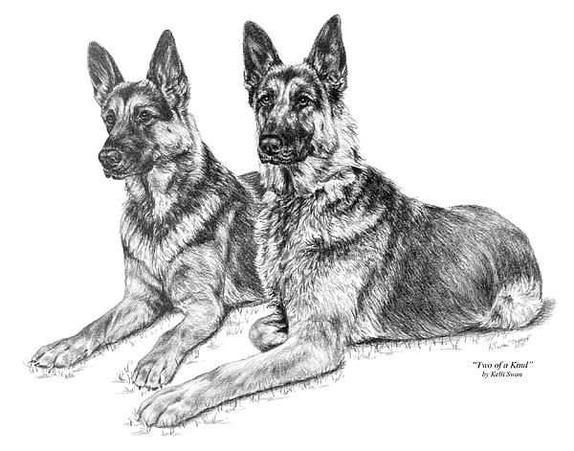
FIGHTING DOGS
Most are very stubborn and independent. They are usually extremely bonded and affectionate with their owners. They are very aggressive towards other dogs and people who are not their owner.
BREEDS INCLUDE: Pit Bull Terrier, Bull Terrier.
They are often small and strongly muscled dogs.
TYPICAL BEHAVIORAL PROFILE: Lively, affectionate, bonded, predatory, very focused.
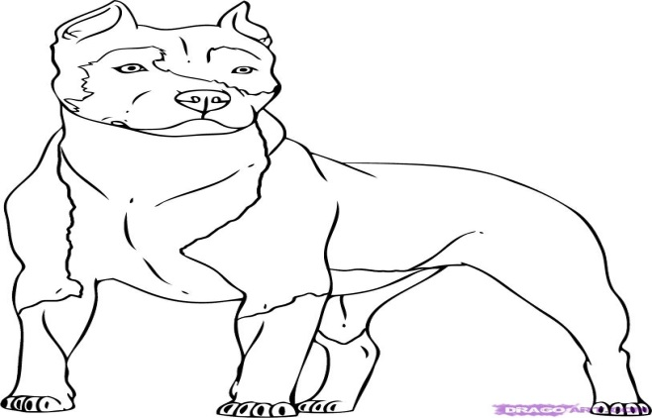

SCENT HOUNDS
Scent Hounds are master smellers, in a species with an absolutely amazing ability to smell. Most scent hounds have long ears - in Bloodhounds and Bassets, so long that the ears sometimes scrape the ground and stir up even more scents. They are used in customs and by the police to look for hidden illegal substances. They can also be used in disaster areas to look for lost people.
BREEDS INCLUDE: Beagles and basset.
TYPICAL BEHAVIORAL PROFILE: Sweet tempered and tolerant, excellent for families. Rarely bite.
TYPICAL PROBLEMS: Often wander off to follow interesting smells.
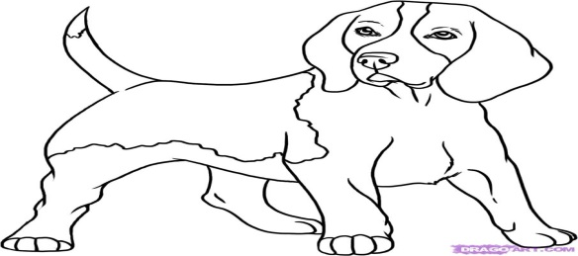

Decide what the dogs in the table below might have been bread for?(Protection, fighting or Scent). Give a reason for your choice.
Picture | What has it been bread for | Reason for your choice.


